Classwork Chapter 1

1. How many significant figures in the following:

  - 12 _____ c ) 0.0000101 _____

  - 2.001 X 10³ _____ d) 22.04030 _____

2. Round each of the following numbers to three significant figures. [Then write in exponential notation.]
  - 312.54 ______________ = ________________

  - 0.00003549 ______________ = ________________

  - 31,245,805 ______________ = _________________

3. Based on the molecular diagram, classify each change as physical or chemical.
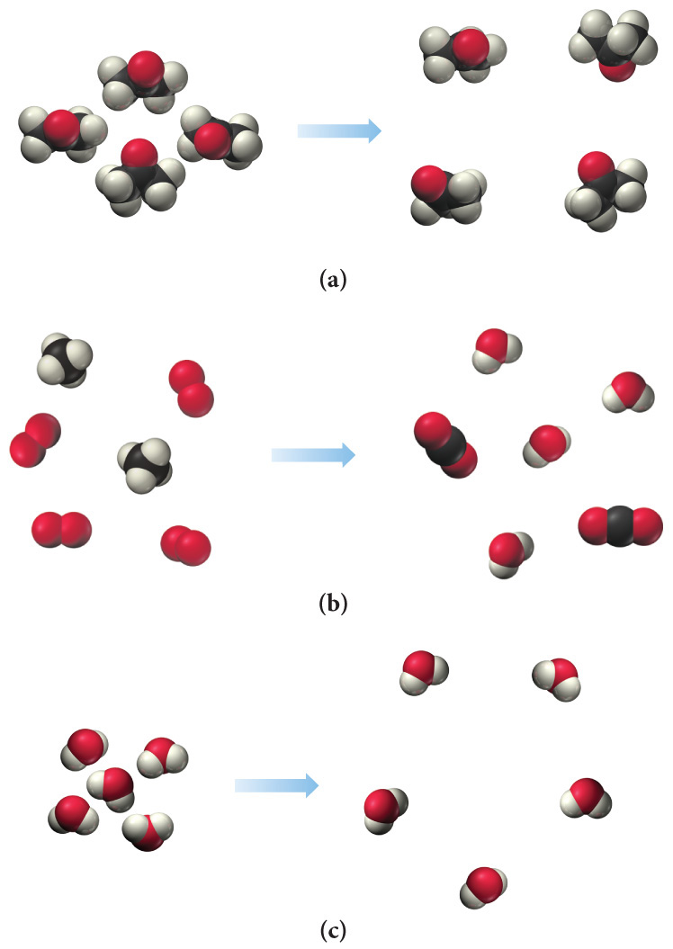
4. Perform the following mathematical operations, and express each result to the correct number of significant figures.
  - 78.098 + 4.2 + 0.5675 = _________________

  - 117.5 + 27.915 −.23 = _________________

5. Complete the table. Convert all numbers to three significant figures.

1245 kg | g | mg
254,998 ml | DL | L
22 X 10⁵ nm | m | km
355 km/sec | cm/sec | m/sec

6. How close a measurement is to the true value is the ________ of the measurement and is communicated as __________
a) accuracy, % error
b) accuracy, ± notation
c) precision, % error
d) precision, ± notation

7. Determine whether each molecular diagram represent a pure substance or a mixture. If it represents a pure substance, classify it as an element or compound. If it represents a mixture, classify the mixture as an element
or compound.
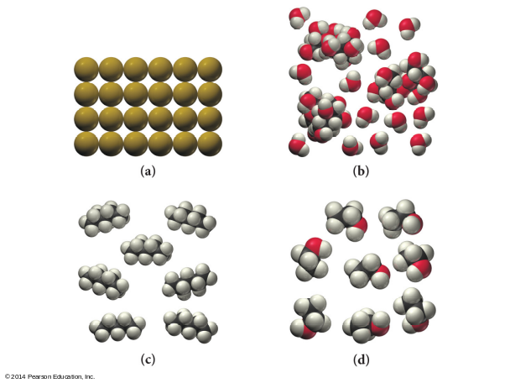

8. 8.56 X 10⁻³ nm = __?__ μm _______________________

9. Given: 1 rod = 5.5 yd; 1 furlong = 40 rods; 1 mile = 8 furlongs [All exact numbers]
Convert 1.25 miles to:

a) rods _________________

b) yards _________________

10. The following target represents someone who is:
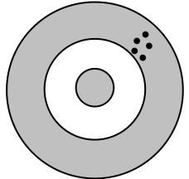
a) accurate, but not precise
b) precise, but not accurate
c) both precise and accurate
d) neither precise, nor accurate

12. Ethanol has a density of 0.789 g/cm³.
a. What is the mass of 225 cm³ of ethanol?

b. What is the volume of 75.0 g of ethanol?
‘
13. If 1 inch = 2.54 cm, 12 in = 1 foot, 5280 ft = 1 mile:
How many centimeters are there in 4.57 miles?

Gold has a density of 19.3 g/ cm³. A cube of gold measures 4.23 cm on each edge:
14. What is the volume of the cube?

15 What is its mass? How many significant figures should you include in your answer and why?

16. A chemical plant releases 5.0 tons of gas into the atmosphere each day. The gas contains 5.0% by mass of sulfur dioxide. What mass (in tons) of sulfur dioxide is released in a period of one week?

17-18 Using the matter classification schema, identify the following as an element, compound, solution or heterogeneous mixture.

17. White gold,” used in jewelry, contains gold and another “white” metal such as palladium. Two different samples of white gold differ in the relative amounts of gold and palladium that they contain. Both samples are uniform in composition throughout. Without knowing any more about the materials, classify white gold.

18. Aspirin is composed of 60.0% carbon, 4.5% hydrogen, and 35.5% oxygen by mass, regardless of its source.

19. The process used to separate heterogeneous mixtures of solids and liquids is called?
A: filtration C: distillation
B: crystallization or evaporation D: chromatography

20. A technique that separates a mixture based on the individual substance's tendency to travel across a surface is called ___________.
A: filtration C: distillation
B: crystallization or evaporation D: chromatography

21.The formation of pure solid particles of a substance from a solution is called __________.
A: filtration C: distillation
B: crystallization or evaporation D: chromatography

22. Suspensions are best separated by which process?
A: filtration C: distillation
B: crystallization or evaporation D: chromatography

23. Some solutions, such as salt water, are separated by which process?
A: filtration C: distillation
B: crystallization or evaporation D: chromatography

